# A000-Asia-Gandhara-Bodhisattva bust in architrave-Green schist-ca. 100-200 CE

# Case No.: 3

# Size 10.3 cm height - 14 cm length, no restoration, fine condition *Bodhisattva* is the Sanskrit term () in Mahayana Buddhism, for one motivated by great compassion, or *bodhi-citta* (in Sanskrit, meaning “mind of enlightenment” or “spirit of awakening,” from *bodhi*, “enlightenment” and *cittá*, “mind”) for the benefit of all sentient beings.

Sold by [sa2010*10](http://myworld.ebay.com/sa2010*10) ( [502](http://feedback.ebay.com/ws/eBayISAPI.dll?ViewFeedback&userid=sa2010*10) )

### Delivery package 1 of 1

Estimated delivery Friday, Jan 29, 2016 - Wednesday, Feb 17, 2016

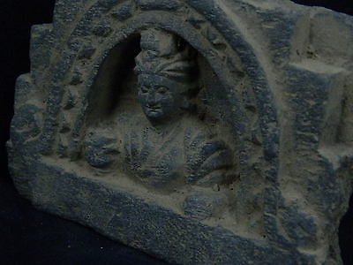

#### [Gandhara/Gandharan Stone Bodhasattva Bust 200 AD](http://www.ebay.com/itm/271628428980)

|  |  |
| --- | --- |
| Item price | $200.00 |
| Quantity | 1 |
| Item number | 271628428980 |
| Shipping service | Economy Shipping from outside US |

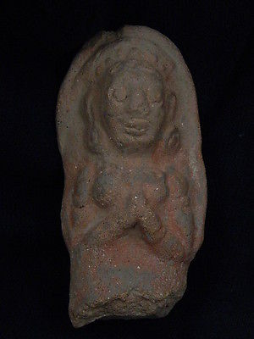

#### [Ancient Gandhara/Gandharan Teracotta Figure 200 AD](http://www.ebay.com/itm/281632541047)

|  |  |
| --- | --- |
| Item price | $90.00 |
| Quantity | 1 |
| Item number | 281632541047 |
| Shipping service | Economy Shipping from outside US |